***Lecture Three − Infinite Sequences and Series***

***Section* 3.1 – Sequences**

A sequence is a list of numbers



An ***infinite sequence*** of numbers is a function whose domain is the set of positive integers. These are the ***terms*** of the sequence. The integer ***n*** is called the ***index*** of .

Sequences can be described by writing rules that specify their terms such as



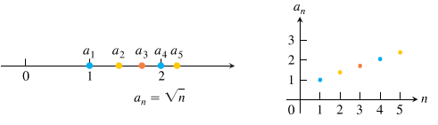



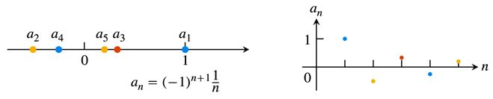



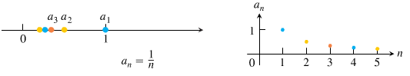

Also, we can write: 

**Convergence and Divergence**

 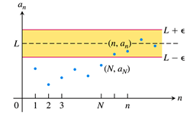

 Terms approach 1.

 Terms approach 0.

***Definition***

The sequence  ***converges*** to the number *L* if for every positive number *ε* there corresponds an integer *N* such that for all *n*,



If no such number *L* exists, we say  ***diverges***.

The  ***converges*** to *L*, we write , or simply , and call *L* the ***limit*** of the sequence.

***Example***

Show that 

***Solution***

Let ε > 0 be given. We must show that there exists an integer *N* such that for all *n*,



This implication will hold if  or . If *N* is any integer greater than , the implication will hold for all *n* > *N*. This proves that 

***Example***

Show that 

***Solution***

Let ε > 0 be given. We must show that there exists an integer *N* such that for all *n*,



Since , we can use any positive integer for *N* and the implication will hold for all *n* > *N*. This proves that 

***Definition***

The sequence  ***diverges*** to infinity if for every number *M* there is an integer *N* such that for all *n* larger than *N*, . If this condition holds we write



Similarly, if for every number *m* there is an integer *N* such that for all *n* > *N* we have , then we say  ***diverges to negative infinity*** and write



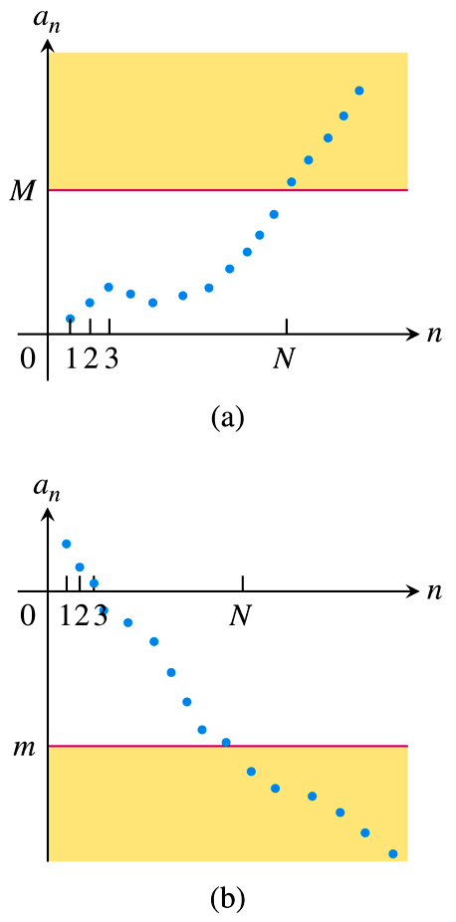 

***Theorem***

Let and  be sequences of real numbers, and let *A* and *B* real numbers. The following rules hold if  and 

***Sum Rule***: 

***Difference Rule***: 

***Constant Multiple Rule***: 

***Product Rule***: 

***Quotient Rule***: 

***Example***

1. 
2. 
3. 
4. 

***Theorem*** − ***The Sandwich Theorem for Sequences***

Let , and  be sequences of real numbers. If  holds for all *n* beyond some index *N*, and if  , then  also.

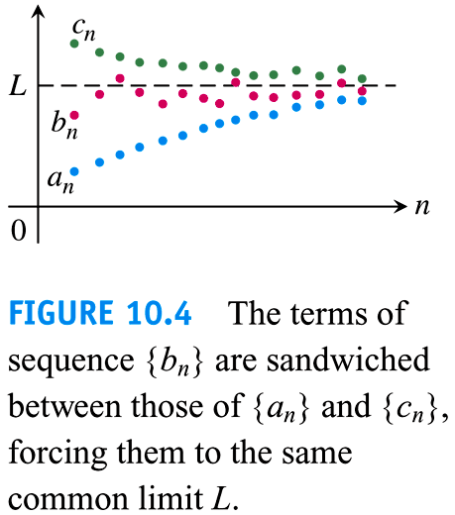

***Example***

Since , we know that

1. 
2. 
3. 

***Theorem*** − ***The Continuous Function Theorem for Sequences***

Let  be a sequence of real numbers. If  and if  is a function that is continuous at L and defined at all , then .

***Example***

Show that 

***Solution***

We know that . Taking  and *L* = 1 that gives 

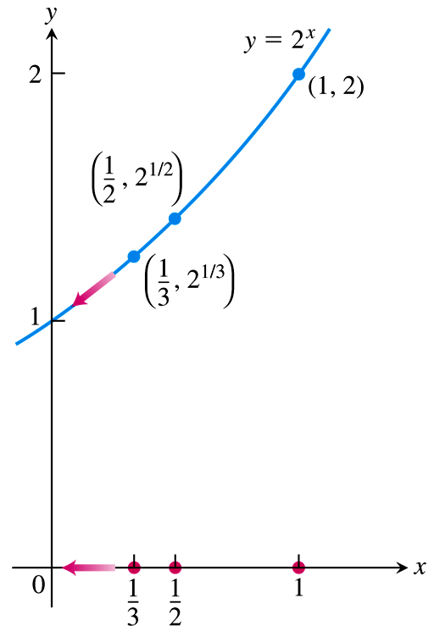

***Example***

The sequence  converges to 0.

By taking , , and *L* = 0.

We see that .

The sequence  converges to 1.

***Using L’Hôpital’s Rule***

***Theorem***

Suppose that  is a function for all  and that  is a sequence of real numbers such that  for . Then



***Example***

Show that 

***Solution***

The function  is defined for all  and agrees with the given sequence at positive integers. Therefore, 

***Example***

Does the sequence whose *n*th term is  converge? If so, find 

***Solution***

The limit leads to the indeterminate form .



 **∞.0 *form***

 **0.0 *form***

 







***Theorem***

The following six sequences converge to the limits listed below:

1. 
2. 
3. 
4. 
5. 
6. 

**Bounded *Monotonic* Sequences**

***Definitions***

A sequence  is ***bounded from above*** if there exists a number *M* such that  for all *n*. The number *M* is an ***upper bound*** for  but no number less than *M* is an upper bound for , then *M* is the ***least upper bound*** for .

A sequence  is ***bounded from below*** if there exists a number *m* such that  for all *n*. The number *m* is an ***lower bound*** for . If *m* is a lower bound for  but no number greater than *m* is a lower bound for , then *m* is the ***greatest lower bound*** for .

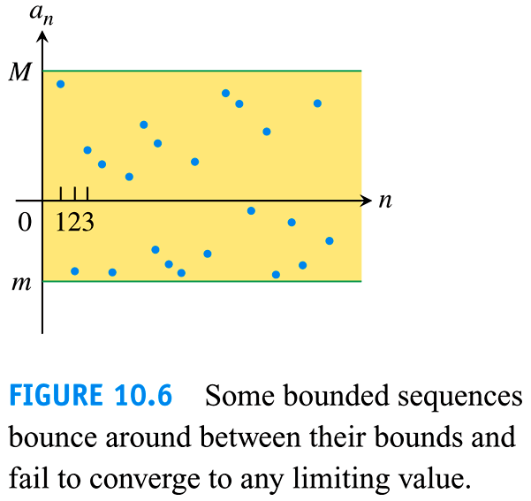If  is bounded from above and below, the is ***bounded***.

If  is not bounded, then  is an ***unbounded*** sequence.

***Definition***

A sequence  is ***nondecreasing*** if  for all *n*. That is 

Which each term is greater than or equal to its predecessor 

***Example***: 

A sequence  is ***nonincreasing*** if  for all *n*, which each term is less than or equal to its predecessor 

***Example***: 

The sequence  is ***monotonic*** if it is either nondecreasing or nonincreasing.

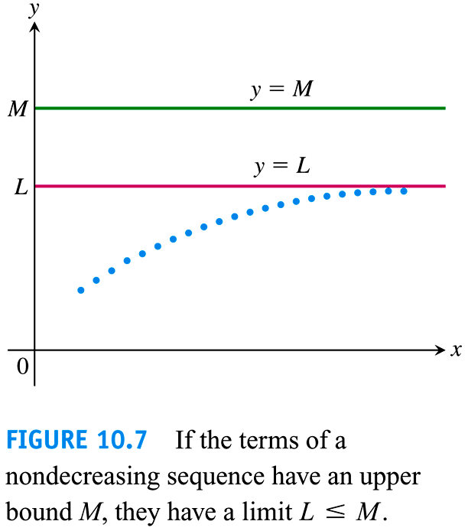

***Theorem***

If a sequence  is both *bounded* and *monotonic*, then the sequence converges.

***Example***

The sequence {1, 2, 3, …, *n*, …} is nondecreasing

The sequence  is nondecreasing

The sequence  is nonincreasing

***Exercises*** ***Section* 3.1 – Sequences**

1. Find the values of for 
2. Find the values of for 
3. Find the values of for 
4. Find the values of for 
5. Find the values of for 
6. Write the first ten terms of the sequence 
7. Write the first ten terms of the sequence 
8. Write the first ten terms of the sequence 
9. Find a formula for the *n*th term of the sequence 
10. Find a formula for the *n*th term of the sequence 
11. Find a formula for the *n*th term of the sequence 
12. Find a formula for the *n*th term of the sequence 
13. Find a formula for the *n*th term of the sequence 
14. Find a formula for the *n*th term of the sequence 

Determine if the sequence converge or diverge? Then find the limit of each convergent sequence.

|  |  |  |  |  |  |
| --- | --- | --- | --- | --- | --- |
|  | |  |  | | |
|  | |  | | |  |

***Section* 3.2 – Infinite Series**

An ***infinite series*** is the sum of an infinite sequence of numbers



The sum of the first *n*th terms



|  |  |  |  |
| --- | --- | --- | --- |
| ***Partial Sum*** |  | ***Value*** | ***Suggestive Expression***  ***For Partial Sum*** |
| First: |  | 1 | 2 − 1 |
| Second |  |  |  |
| Third: |  |  |  |
|  |  |  |  |
|  |  |  |  |

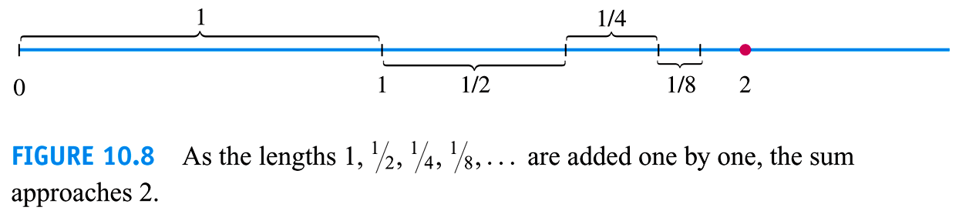

***Definition***

Given a sequence of numbers , an expression of the form  is an ***infinite series***. The number  is the ***n*th term** of the series. The sequence  is defined by











Is the ***sequence of partial sums*** of the series, the number  being the ***n*th partial sum**. If the sequence of partial sums converges to a limit L, we say that the series **converges** and that its **sum** is *L*. In this case, we also write



If the sequence of partial sums of the series does not converge, we say that the series diverges.

***Geometric* Series**

Geometric series are series of the form



In which *a* and *r* are fixed real numbers, and . The series can also be written as 

**Definition of *Geometric* Sequence**

A sequence  is a geometric sequence if  and if there is a real number  such that for every positive integer *k*.



The number  is called the ***common ratio*** of the sequence.

***The formula for the nth Term of a Geometric Sequence***: 

***Theorem*: Formula for **

The *n*th partial sum  of a geometric sequence with first term  and common ratio  is



***Proof***

By definition, the *nth* partial sum  of a geometric sequence is:







***Definition***

If , the geometric series converges to 



If , the series diverges.



* The sequence may converge to a single value, which is the limit of the sequence.
* The sequence terms may increase in magnitude without bound (either with one sign or with mixed signs), in which case the sequence diverges.
* The sequence terms may remain bounded but settle into an oscillating pattern in which the terms approach two or more values, then the sequence diverges.
* The terms of a sequence may remain bounded, but wander chaotic forever without pattern, then the sequence diverges in this case.

***Example***

Find the geometric series with 

***Solution***







***Example***

The series  is geometric series with 

***Solution***

It converges to 





***Example***

Your drop a ball from *a* meters above a flat surface. Each time the ball hits the surface after falling a distance *h*, it rebounds a distance *rh*, where *r* is positive but less than 1. Find the total distance the ball travels up and down. 

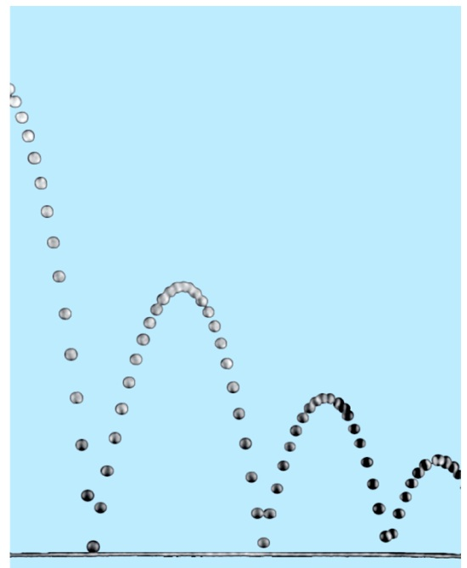 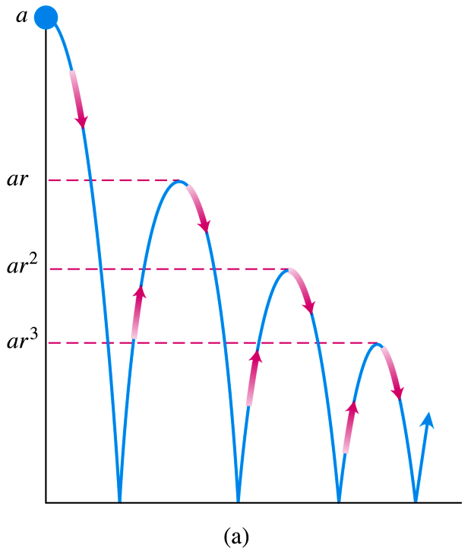

***Solution***

The total distance is









If , the distance is:



***Example***

Express repeating decimal 5.232323… as the ratio of two integers.

***Solution***













***Example***

Find the sum of the “telescoping” series .

***Solution***













**The *n*th-Term Test for a Divergent Series**

***Theorem***

If  converges, then 

***The nth-Term Test for Divergence***

diverges if  fails to exist or is different from zero.

***Example***

1. The series  diverges because each term is greater than 1, so the sum of the *n* terms is greater than *n*. 
2.  diverges because 
3.  diverges because  doesn’t exist.
4.  diverges because 

***Theorem***

If  and  are convergent series, then

***Sum Rule:*** 

***Difference Rule:*** 

***Constant Multiple Rule:*** 

* Every nonzero constant multiple of a divergent series diverges.
* If  converges and  diverges, then  and  both diverge.

***Example***

Find the sums of the series 

***Solution***













***Example***

Find the sums of the series 

***Solution***









**Adding or Deleting Terms**

We can add finite number of terms to a series or delete a finite number of terms without altering the series’ convergence or divergence.









***Exercises*** ***Section* 3.2 – Infinite Series**

Find the limit of the following sequences or determine the limit does not exist

|  |  |  |
| --- | --- | --- |
|  |  |  |

Find a formula for the *n*th term partial sum of the series and use it to find the series’ sum if the series converges

1. 
2. 
3. 
4. 
5. 

Write out the first few terms of each series to show how the series starts. Then find the sum of the series

|  |  |
| --- | --- |
|  |  |

Determine if the geometric series converges or diverges. If a series converges, find its sum

1. 
2. 
3. 

Express each of the numbers as the ratio of two integers (fraction)

1. 
2. 
3. 
4. 

Determine if the series converges or diverges. Give reasons for your answers. If a series converges, find its sum.

|  |  |  |
| --- | --- | --- |
|  |  |  |

Determine if the series converges or diverges and describe whether they do so monotonically or by oscillation. Give the limit when the sequence converges.

|  |  |  |
| --- | --- | --- |
|  |  |  |

Find the limit of the following sequences or state that they diverge

|  |  |
| --- | --- |
|  |  |

1. Many people take aspirin on a regular basis as a preventive measure for heart disease. Suppose a person take 80 mg of aspirin every 24 hr. Assume also that aspirin has a half-life of 24 hr; that is, every 24 hr half of the drug in the blood is eliminated.
2. Find a recurrence relation for the sequence  that gives the amount of drug in the blood after the *nth* dose, where 
3. Find the limit of 
4. Suppose a tank is filled with 100L of a 40% alcohol solution (by volume). You repeatedly perform the following operation: Remove 2 L of the solution from the tank and replace them with 2 L of 10% alcohol solution
5. Let  be the concentration of the solution in the tank after the nth replacement, where . Write the first five terms of the sequence 
6. After how many replacements does the alcohol concentration reach 15%?
7. Determine the limiting (steady-state) concentration of the solution that is approached after many replacements.
8. The Greeks solved several calculus problems almost 2000 years before the discovery of calculus. One example is Archimedes’ calculation of the area of the region *R* bounded by a segment of a parabola, which he did using the “method of exhaustion”.

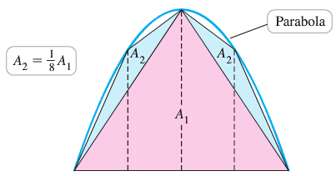

The idea was to fill *R* with an infinite sequence of triangles. Archimedes began with an isosceles triangle inscribed in the parabola, with an area , and proceeded in stages, with the number of new triangles doubling at each stage. He was able to show (the key to the solution) that at each stage, the area of a new triangle is  of the area of a triangle at the previous stage; for example, , and so forth. Show, as Archimedes did, that the area of *R* is  times the area of .

1. Evalute the series 
2. For what values of a does the the series converge, and in those cases, what is its value?



1. Suppose you borrow $20,000 for a new car at a monthly interest rate of 0.75%. If you make payments of $600/month, after how many months will the loan balance be zero? Estimate the answer by graphing the sequence of loan balances and then obtain an exact answer using infinite series.
2. An insulated windows consists of two parallel panes of glass with a small spacing between them. Suppose that each pane reflects a fraction *p* of the incoming light and transmits the remaining light. Considering all reflections of light between the panes, what fraction of the incoming light is ultimately transmitted by the windows? Assume the amount of incoming light is 1.

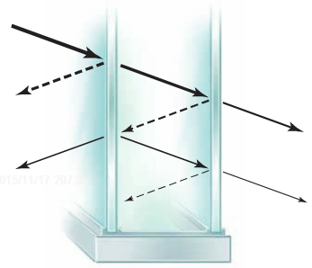

1. Suppose a rubber ball, when dropped from a given height, returns to a fraction *p* of that height. In the absence of air resistance, a ball dropped from a height *h* requires  seconds to fall to the ground, where  is the acceleration due to gravity. The time taken to bounce up to a given to fall from that height to the ground. How long does it take a ball dropped from 10 *m* to come to rest?
2. The fractal called the snowflake island (or Koch island) is constructed as flows: Let  be an equilateral triangle with sides of length 1. The figure  is obtained by replacing the middle third of each side of  with a new outward equilateral triangle with sides of length . The process is repeated where  is obtained by replacing the middle third of each side of with a new outward equilateral triangle with sides of length of . The limiting figure as  is called the snowflake island.

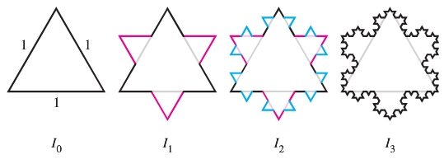

1. Let  be the perimeter of . Show that 
2. Let  be the area of . Find . It exists!
3. Imagine a stack of hemispherical soap bubbles with decreasing radii  Let  be the distance between the diameters of bubble *n* and bubble , and let  be the total height of the stack with *n* bubbles.

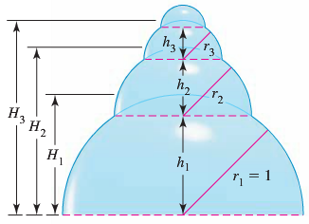

1. Use the Pythagorean theorem to show that in a stack with *n* bubbles , , and so forth. Note that for the last bubble .
2. Use part (*a*) to show that the height of a stack with *n* bubbles is



1. The height of a stack of bubbles depends on how the radii decrease. Suppose that  where  is a fixed real number. In terms of *a*, find the height  of a stack with *n* bubbles.
2. Suppose the stack in part (*c*) is extended indefinitely . In terms of *a*, how high would the stack be?
3. The fractal called the *Sierpinski* *triangle* is the limit of a sequence of figures. Starting with the equilateral triangle with sides of length 1, an inverted equilateral triangle with sides of length  is removed. Then, the three inverted equilateral triangles with sides of length  are removed from this figure.

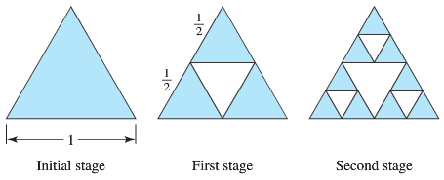

The process continues in this way. Let  be the total area of the removed triangles after stage *n* of the process. The area on equilateral triangle with side length *L* is .

1. Find  and  the total area of the removed triangles after stages 1 and 2, respectively.
2. Find  for 
3. Find 
4. What is the area of the original triangle that remains as ?
5. The sides of a ***square*** are 16 *inches* in length. A new square is formed by connecting the midpoints of the sides of the original square, and two of the triangles outside the second square are shaded.



Determine the area of the shaded regions

1. When this process is continued five more times
2. When this pattern of shading is continued infinitely.
3. A right triangle *XYZ* is shown below where  and . Line segments are continually drawn to be perpendicular to the triangle.



1. Find the total length of the perpendicular line segments  in terms of *z* and *θ*.
2. Find the total length of the perpendicular line segments when  and 
3. The sphereflake is a computer−generated fractal that was created by Eric Haines. The radius of the large sphere is 1. To the large sphere, nine spheres of radius  are attached. To each of these, nine spheres of radius  are attached. This process is continued infinitely.

Prove that the sphereflake has an infinite surface area.



***Section* 3.3 – Integral Test**

**Nondecreasing Partial Sums**

Suppose that  is an infinite series with  for all *n*. Then each partial sum is greater than or equal to its predecessor because :



***Corollary***

A series  of nonnegative terms converges if and only if its partial sums are bounded from above.

***Example***

The series 

***Solution***



The sum of the first 2 terms is 1.5.

The sum of the next 2 terms is 

The sum of the next 4 terms is 

  

The sum of  terms ending with  is 

The sequence of partial sums is not bounded from above: If , the partial sum .

The harmonic series diverges.

**The Integral Test**

***Theorem***

Let  be a sequence of positive terms. Suppose that , where  is a continuous, positive, decreasing function of *x* for all  (*N* a positive integer). Then the series  and the integral  both converge or both diverge.

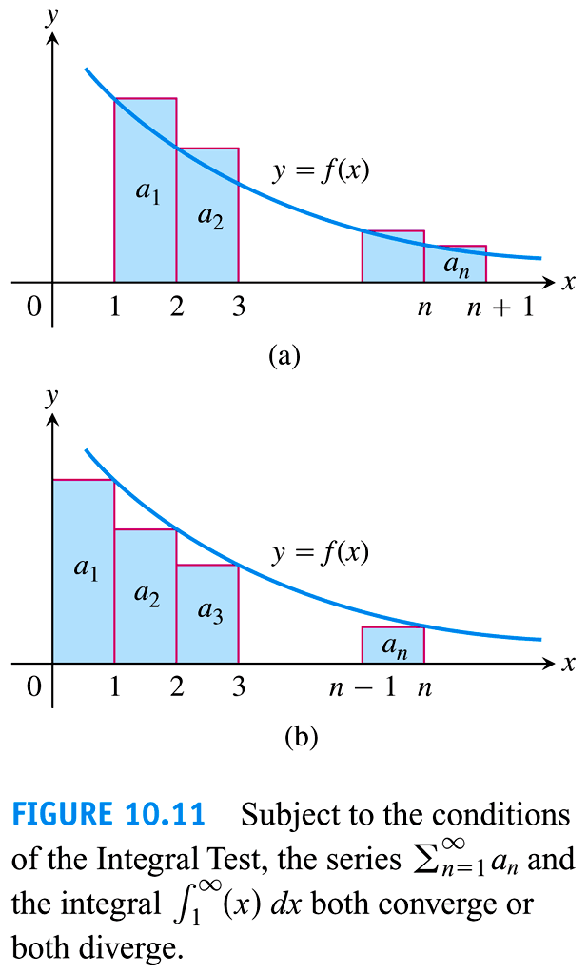 

***Example***

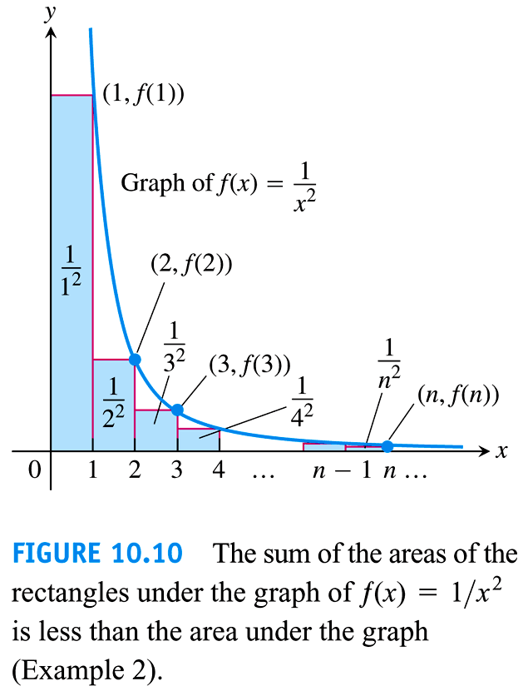Does the following series converge? 

***Solution***











Thus the partial sums are bounded from above by 2 and the series converges.



***p*-*series***

***Example***

Show that the ***p***-*series* 

(*p* a real constant) converges if *p* > 1, and diverges if *p* ≤ 1.

***Solution***





 ***p* > 1**





The series converges when *p* > 1.

if *p* ≤ 1 ⇒  ⇒ The series diverges.

***Example***

Does the following series converge 

***Solution***









The series converges, but we do not know the value of its sum

**Bounds for the Remainder in the Integral Test**

Suppose  is a sequence of positive terms with , where  is a continuous positive decreasing function of *x* for all *x* ≥ *n*, and that  converges to *S*. Then the remainder  satisfies the inequalities



***Example***

Estimate the sum of the series  with *n* = 10

***Solution***















If we approximate the sum S by the midpoint of this interval, then



The error in this approximation is less than half the length of the interval, so the error is less than 0.005.

***Exercises Section* 3.3 – Integral Test**

Use the integral Test to determine if the series converge or diverge.

|  |  |  |
| --- | --- | --- |
|  |  |  |

Determine if the series converge or diverge

|  |  |  |  |  |
| --- | --- | --- | --- | --- |
|  | |  | |  |
|  |  |  | | |

1. Consider a wedding cake of infinite height, each layer of which is a right circular cylinder of height 1. The bottom layer of the cake has a radius of 1, the second layer has a radius of , the third layer has a radius of , and the *nth* layer has a radius of .

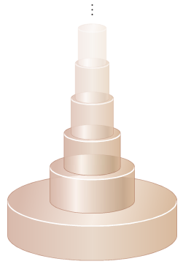

1. To determine how much frosting is needed to cover the cake, find the area of the lateral (vertical sides of the wedding cake. What is the area of the horizontal surfaces of the cake?
2. Determine the volume of the cake.
3. Comment on your answer to parts (*a*) and (*b*)
4. The Riemann zeta function is the subject of extensive research and is associated with several renowned unsolved problems. Is its defined by , when *x* is a real number, the zeta function becomes a *p-*series. For even positive integers *ρ*, the value of  is known exactly. For example,



1. Use the estimation techniques to approximate  and  (whose values are not known exactly) with a remainder less than .
2. Determine the sum of the reciprocals of the squares of the odd positive integers by rearranging the terms of the series  without changing the value of the series.
3. Consider a set of identical dominoes that are 2 inches long. The dominoes are stacked on top of each other with their long edges aligned so that each domino overhangs the one beneath is as far as possible
4. If there are *n* dominoes in the stack, what is the greatest distance that the top domino can be made to overhang the bottom domino? (*Hint*: Put the *nth* domino beneath the previous  dominoes.)
5. If we allow for infinitely many dominoes in the stack, what is the greatest distance that the top domino can be made to overhang the bottom domino?

***Section* 3.4 – Comparison Tests**

***Theorem***

Let , , and  be series with nonnegative terms. Suppose that for some integer *N*.



1. If  converges, then  also converges.
2. If  diverges, then  also diverges.

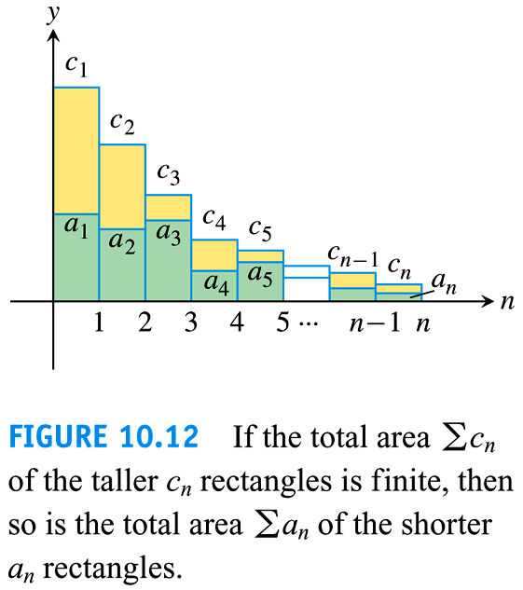

***Example***

Use the comparison Test to determine if  converges or diverges.

***Solution***



The series diverges because its *n*th term is greater than the *n*th term of the divergent harmonic series.

***Example***

Use the comparison Test to determine if  converges or diverges.

***Solution***

 The series converges.

***Theorem* − Limit Comparison Test**

Suppose that  and  for all  (*N* an integer)

1. If , then  and  both converge or both diverge
2. If  and  converges, then  converges
3. If  and  diverges, then  diverges

***Example***

Does the series  converge or diverge?

***Solution***



Let 



Since 

  diverges

***Example***

Does the series  converge or diverge?

***Solution***

Let 

Since 







 converges by the Limit Comparison Test.

***Example***

Does the series  converge or diverge?

***Solution***

Let 









 diverges by the Limit Comparison Test.

***Example***

Does the series  converge?

***Solution***

Let 





 ***L’hôpital Rule***





 converges by the Limit Comparison Test.

***Exercises*** ***Section* 3.4 – Comparison Tests**

Use the Comparison Test to determine if the series converges or diverges.

|  |  |  |
| --- | --- | --- |
|  |  |  |

Use the Limit Comparison Test to determine if the series converges or diverges.

|  |  |  |
| --- | --- | --- |
|  |  |  |

Use any method to determine if the series converges or diverges

|  |  |  |
| --- | --- | --- |
|  |  |  |

***Section* 3.5 – The Ratio and Root Tests**

***Theorem* − The Ratio Test**

Let  be a series with positive terms and suppose that



Then

1. the series ***converges*** if ρ < 1,
2. the series ***diverges*** if ρ > 1, or ρ is infinite
3. the test is ***inconclusive*** if ρ = 1,

The value ρ doesn’t mean the sum of the series.

***Example***

Investigate the convergence of the series 

***Solution***



The series converges since ρ < 1.









***Example***

Investigate the convergence of the series 

***Solution***











The series diverges since ρ > 1.

***Example***

Investigate the convergence of the series 

***Solution***









Because the limit is ρ = 1, we can’t decide from the Ratio Test whether the series converges.

However, since , then the series diverges.

***Theorem* − The Root Test**

Let  be a series with  for , and suppose that



Then

1. the series ***converges*** if ρ < 1,
2. the series ***diverges*** if ρ > 1, or ρ is infinite
3. the test is ***inconclusive*** if ρ = 1,

***Example***

Determine if the series  converges or diverges using the Root Test

***Solution***

 The series converges by the Root Test.

***Example***

Determine if the series  converges or diverges using the Root Test

***Solution***

 The series diverges by the Root Test.

***Example***

Determine if the series  converges or diverges using the Root Test

***Solution***

 The series converges by the Root Test.

***Exercises*** ***Section* 3.5 – The Ratio and Root Tests**

Use the Ratio Test to determine if the series converges or diverges.

|  |  |  |
| --- | --- | --- |
|  |  |  |

Use the Root Test to determine if the series converges or diverges.

|  |  |  |
| --- | --- | --- |
|  |  |  |

|  |  |  |
| --- | --- | --- |
|  |  |  |

Use any method to determine if the series converges or diverges.

|  |  |  |
| --- | --- | --- |
|  |  |  |
|  |  |  |

|  |  |  |
| --- | --- | --- |
|  |  |  |

1. Use the integral test to show that  converges. Show that the sum *s* of the series is less than 
2. Use the root test to show that  converges
3. Use the root test to test that  converges
4. Try to use the ratio test to determine whether  converges. What happen?

Now observe that 



Does the given series converge? Why or why not?

1. Suppose  and  for all *n*. Show that  diverges.



1. Working in the early 1600s, the mathematicians Wallis, Pascal, and Fermat were calculating the area of the region under the curve  between  and , where *p* is the positive integer. Using arguments that predated the Fundamental Theorem of Calculus, they were able to prove that



Use Riemann sums and integrals to verify this limit.

1. Complete the following steps to find the values of  for which the series  converges
2. Use the Ratio Test to show that  converges for .
3. Use Stirling’s formula,  for large *k*, to determine whether the series converges when .



***Section* 3.6 – Alternating Series, Absolute and Conditional Convergence**

A series in which the terms are alternately positive and negative is an alternating series.





***Theorem* − The Alternating Series Test (Leibniz’s Test)**

The series 

Converges if all three of the following conditions are satisfied:

1. The  are all positive.
2. The positive  are (eventually) non-increasing:  for all , for some integer N.
3. 

***Example***

The alternating harmonic series 

***Solution***

1. 
2. 
3. 

Therefore, the series converges.

***Theorem* − The Alternating Series Estimation Theorem**

IF the alternating series  satisfies the three conditions, then for 



Approximates the sum *L* of the series with an error whose absolute values is less than , the absolute value of the first unused term. Furthermore, the sum L lies between any two successive partial sums  and  and the remainder, , has the same sign as the first unused term.

**Absolute and Conditional Convergence**

***Definition***

A series  ***converges absolutely*** (is ***absolutely convergent***) if the corresponding series of absolute values, , converges.

***Definition***

A series converges but does not converge absolutely ***converges conditionally***.

***Theorem***

If  converges, then  converges.

***Example***

For  the corresponding series of absolute values is the convergent series



The original series converges because it converges absolutely.

***Example***

For  , which contains both positive and negative terms, the corresponding series of absolute values is



Which converges by comparison with  because  for every *n*.

The original series converges absolutely; therefore, it converges.

**Rearranging Series**

***Theorem***

If  converges absolutely, and  is any arrangement of the sequence , then  converges absolutely and 

***Exercises Section* 3.6 – Alternating Series, Absolute and Conditional Convergence**

Determine if the alternating series converges or diverges

|  |  |  |
| --- | --- | --- |
|  |  |  |

Determine if the series converge absolutely or conditionally, or diverges

|  |  |  |
| --- | --- | --- |
|  |  |  |

|  |  |  |
| --- | --- | --- |
|  |  |  |

For what values of *x* does the series converge absolutely? Converge conditionally? Diverge?

|  |  |  |
| --- | --- | --- |
|  |  |  |

Use any method to determine if the series converges or diverges.

|  |  |  |
| --- | --- | --- |
|  |  |  |

1. Use a Riemann sum argument to show that 

Then for what values of *x* does the series  converge absolutely? Converge conditionally? Diverge? (*Use the ratio test first*)

1. It can be proved that if a series converges absolutely, then its terms may be summed in any order without changing the value of the series. However, if a series converges conditionally, then the value of the series depends on the order of summation. For example, the (conditionally convergent) alternating harmonic series has the value



Show that by rearranging the terms (so the sign pattern is ++−),



1. A crew of workers is constructing a tunnel through a mountain. Understandably, the rate of construction decreases because rocks and earth must be removed a greater distance as the tunnel gets longer. Suppose that each week the crew digs 0.95 of the distance it dug the previous week. In the first week, the crew constructed 100 *m* of tunnel.
2. How far does the crew dig in 10 *weeks*? 20 *weeks*? *N* weeks?
3. What is the longest tunnel the crew can build at this rate?
4. The time required to dig 100 *m* increases by 10% each *week*, starting with 1 *week* to dig the first 100 *m*. Can the crew complete a 1.5 *km* tunnel in 10 *weeks*? Explain.
5. Consider the alternating series



1. Write out the first ten terms of the series, group them in pairs, and show that the even partial sums of the series form the (divergent) harmonic series.
2. Show that 
3. Explain why the series diverges even though the terms of the series approach zero.

***Section* 3.7 – Power Series**

**Power Series and Converge**

***Definitions***

A **power series about *x* = 0** is a series of the form 

A **power series about**  is a series of the form



In which the ***center*** *a* and the ***coefficients***  are constants.

***Example***

Find the convergence of 

***Solution***

This is the geometric series with first term 1 and ratio *x*. it converges to 



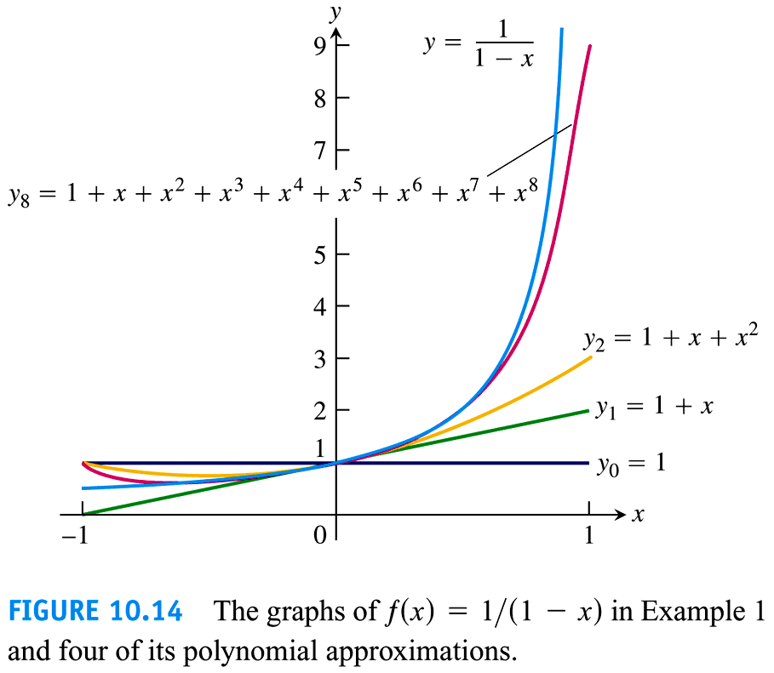

***Example***

The power series 

This is the geometric series with first term 1 and ratio . it converges to . The sum





The series generates polynomial approximations of  for values of *x* near 2:







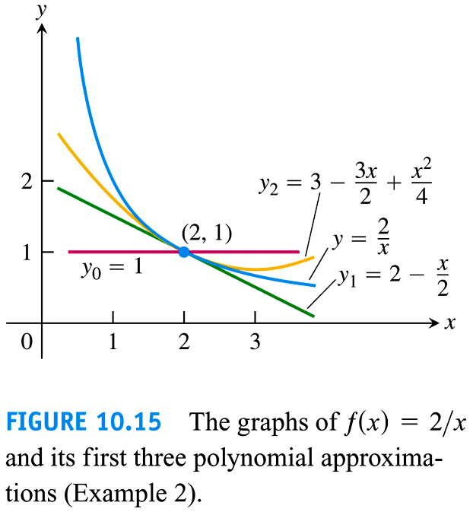

***Example***

For what values of *x* do the power series converges? 

***Solution***



The series converges absolutely for . It diverges if .

At , we get the alternating harmonic series , which converges.

At , we get the alternating harmonic series , the negative of the harmonic series; it diverges.

The series converges for  and diverges elsewhere.



***Example***

For what values of *x* do the power series converges? 

***Solution***



The series converges absolutely for . It diverges if .

At , we get the alternating harmonic series , which converges.

At , we get the alternating harmonic series , it converges.

The series converges for  and diverges elsewhere.



***Example***

For what values of *x* do the power series converges? 

***Solution***



The series converges absolutely for all *x*.



***Example***

For what values of *x* do the power series converges? 

***Solution***



The series diverges absolutely for all *x* except *x* = 0.



***Theorem***

If the power series  converges at , then it converges absolutely for all *x* with . If the series diverges at , then it diverges for all *x* with .

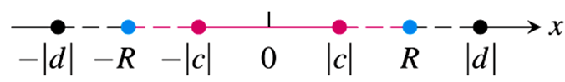

**Radius of Convergence of a Power Series**

***Corollary to Theorem***

The convergence of the series  is described by one of the following three cases:

1. There is a positive number *R* such the series diverges for *x* with  but converges absolutely for *x* with . The series may or may not converge at either of the endpoints  and .
2. The series converges absolutely for every *x* .
3. The series converges at *x* = *a* and diverges elsewhere (*R* = 0)

*R* is called the ***radius of convergence*** of the power series, and the interval of radius *R* centered at *x = a* is called the ***interval of convergence***.

***Definition***

Suppose that  exists or is ∞. Then the power series  has radius of convergence . (If *L* = 0, then *R* = ∞; if *L* = ∞, then *R* = 0) and

***How to Test a Power Series for Convergence***

1. Use the Ratio Test (or Root Test) to find the interval where the series converges. Ordinarily, this is an open interval



1. If the interval of absolute convergence is finite, test for convergence or divergence at each endpoint. Use the Comparison Test, the Integral Test, or the Alternating Series Test.
2. If the interval of absolute convergence is , the series diverges for  (it does not even converge conditionally) because the *n*th term does not approach zero for those values of *x*.

***Example***

Determine the centre, radius, and interval of convergence of 

***Solution***



The centre of convergence is 









The series converges absolutely on ***interval***  

It diverges on 

At 

At 

Both series converge (absolutely).

Therefore, the interval of convergence of the given power is 

***Example***

Determine the radius of convergence of 

***Solution***

|  |  |
| --- | --- |
| Thus | ***Or*** |

This series converges (absolutely) for all *x*.

***Example***

Determine the radius of convergence of 

***Solution***







Thus 

This series converges only at its centre of convergence, *x* = 0.

***Theorem* − The Series Multiplication Theorem for Power Series**

If  and  converge absolutely for , and



Then  converges absolutely to  for :



Finding the coefficients 







***Theorem***

If  converges absolutely for , then  converges absolutely for any continuous function  on 

***Theorem* − The term-by-Term Differentiation Theorem**

If  has a radius of convergence *R* > 0, it defines a function.



This function  has derivatives of all order inside the interval, and we obtain the derivatives by differentiating the original series term by term:





And so on. Each of these derived series converges at every point of the interval 

***Example***

Find the series for  and  if





***Solution***







***Theorem* − The term-by-Term Integration Theorem**

Suppose that  converges for . Then



Converges  and



***Example***

Identify the function 

***Solution***



This is a geometric series with first term 1 and ratio , so 



The series for 



***Exercises Section* 3.7 – Power Series**

1. Find the series’ radius and interval of convergence. For what values of *x* does the series converge (***b***) absolutely, (***c***) conditionally?

|  |  |  |
| --- | --- | --- |
|  |  |  |

Find the radius of convergence of the power series

|  |  |  |
| --- | --- | --- |
|  |  |  |

Find the interval of convergence of the power series

|  |  |  |
| --- | --- | --- |
|  |  |  |

|  |  |  |
| --- | --- | --- |
|  |  |  |

Determine the centre, radius, and interval of convergence of each of the power series

|  |  |  |
| --- | --- | --- |
|  |  |  |

1. For what values of *x* does the series  converges? What is its sum? What series do you get if you differentiate the given series term by term? For what values of *x* does the new series converge? What is its sum?
2. The series  converges to sin*x* for all *x*.
3. Find the first six terms of a series for cos*x*. For what values of *x* should the series converge?
4. By replacing *x* by 2*x* in the series for sin*x*, find a series that converges to sin2*x* for all *x*.
5. Using the result in part (a) and series multiplication, calculate the first six term of a series for . Compare your answer with the answer in part (b).
6. Find the sum of the series  by the first finding the sum of the power series



1. Find a series representation of  in powers of . What is the interval of convergence of this series?
2. Determine the Cauchy product of the series . On what interval and to what function does the product series converge?
3. Determine the power series expansion of  by formally dividing  into 1.

Use the power series 

Determine the interval of convergence and the sum of each of the series

1. 
2. 
3. 

***Section* 3.8 – Taylor and Maclaurin Series**

The sum of a power series:













In general: 

If  has a series representation, then the series must be



**Taylor and Maclaurin Series**

***Definitions***

Let  be a function with derivatives of all orders throughout some interval containing ***a*** as an interior point. Then the ***Taylor series generated by***  at  is



The ***Maclaurin series generated by***  is



The Taylor series generated by  at .

***Example***

Find the Taylor series generated by . Where, if anywhere, does the series converges to .

***Solution***













The Taylor series is:





**Taylor Polynomials**

***Definition***

Let  be a function with derivatives of order *k* for  in some interval containing *a* as an interior point. Then for any integer n from 0 through *N*, the Taylor polynomial of order *n* generated by  at  is the polynomial



***Example***

Find the Taylor series and the Taylor polynomials generated by  at 

***Solution***









This is also the Maclaurin series of 

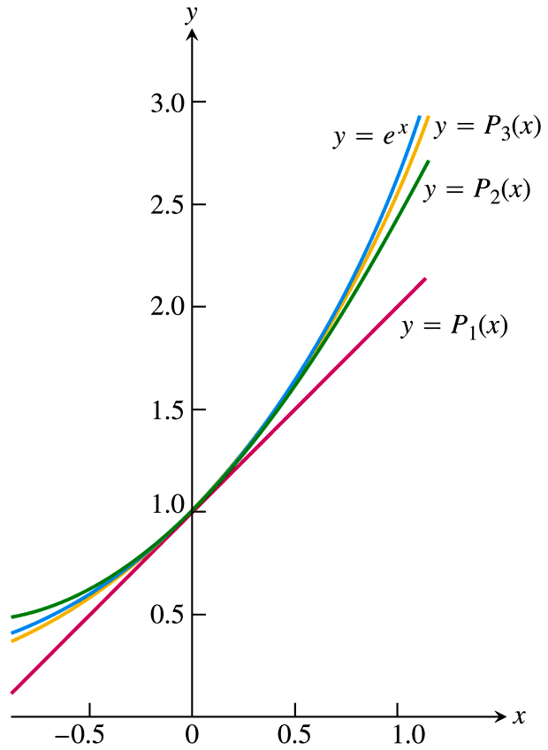

The Taylor polynomial of order *n* at *x* = 0 is



***Example***

Find the Taylor series and the Taylor polynomials generated by  at 

***Solution***





The Taylor series generated by  at  is











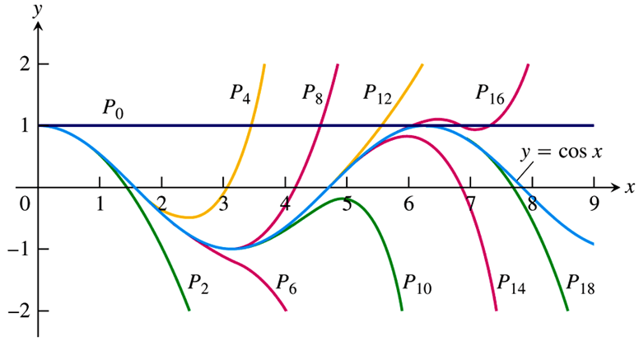

***Example***

Find the Taylor series for  about . Where is the series valid?

***Solution***









This series representation is valid for all *x*.

***Example***

Find the Taylor series for  in powers of . Where does the series converge to ?

***Solution***

Let , then







 

 

 

 

 















Since the series for  is valid for , this series for  is valid for 



***Exercises Section* 3.8 – Taylor and Maclaurin Series**

Find the Taylor polynomials of orders 0, 1, 2, and 3 generated by 

|  |  |
| --- | --- |
|  |  |

Find the *n*th Maclaurin polynomial for the function

|  |  |
| --- | --- |
|  |  |

Find the Maclaurin series for

|  |  |  |
| --- | --- | --- |
|  |  |  |

Finding Taylor and Maclaurin Series generated by 

|  |  |
| --- | --- |
|  |  |

Find the Taylor series of the functions, where is each series representation valid?

|  |  |
| --- | --- |
|  |  |

Find the *n*th Taylor polynomial centered at *c* for the function

|  |  |
| --- | --- |
|  |  |

Find the sums of the series

1. 
2. 
3. 
4. The limit  that is the relative error in the approximation 

Approaches zero as *n* increases. That is *n*! grows at a rate comparable to . This result, known as Stirling’s Formula, is often very useful in applied mathemmatics and statistics. Prove it by carrying out the following steps.

1. Use the identity  and the increasing nature of ln to show that if ,



And hence that 

1. If , show that





1. Use the Maclaurin series for  to show that





and therefore that  is decreasing and  is increasing. Hence conclude that  exists, and that

